Bosch Rexroth to Showcase Innovative Solutions   
at MINExpo 2024

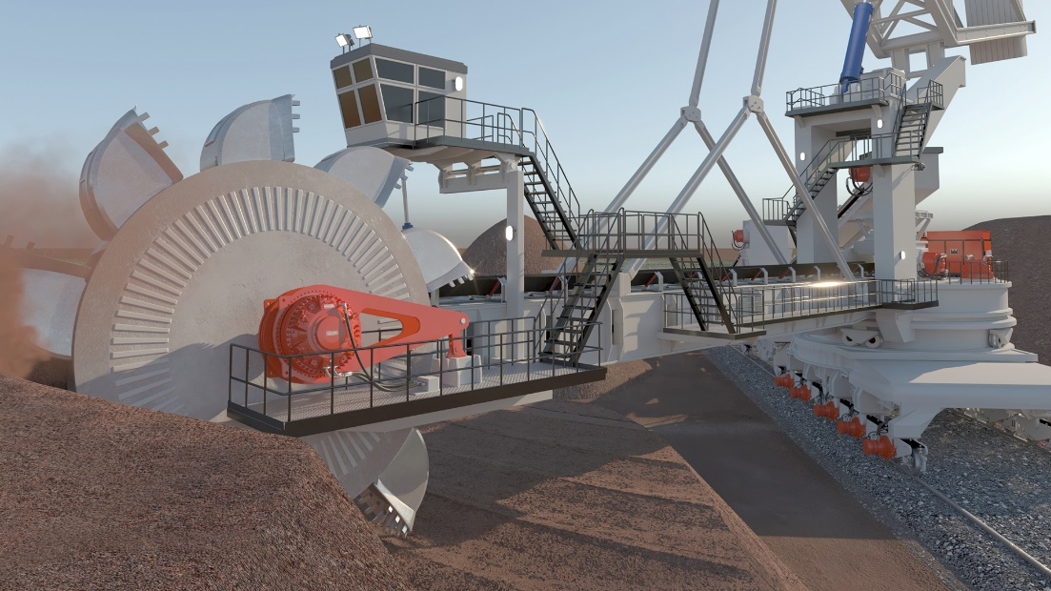

Demonstrations and booth presentations covering multiple Bosch Rexroth hydraulic technologies will be featured at MINExpo 2024, including Hägglunds Drives, booth 10347

Bosch Rexroth, a global leader in drive and control technologies, will participation in MINExpo 2024, the world's largest mining trade show. The event will take place from September 23-26, 2024, at the Las Vegas Convention Center.

At MINExpo 2024, [Bosch Rexroth](http://www.boschrexroth-us.com) will showcase its latest innovations in hydraulic drive and control technologies for the mining industry. Visitors who stop by Bosch Rexroth booth 10347 will have the opportunity to see firsthand how the company's solutions can help improve the efficiency, safety, and sustainability of mining operations.

In addition to showcasing products and solutions, visitors will have the chance to speak with our experts and learn more about how the company's technologies can benefit their mining operations.

**Key booth demos and displays:**  
**HÄGGLUNDS QUANTUM**In mining, mobile applications and more, Hägglunds Quantum motors will reshape reality. Get ready to push the envelope in multiple directions. Hägglunds Quantum is the new name for the Hägglunds CB, which has evolved so significantly over time that it can no longer be considered the same motor. Tweaks in design and materials have increased its efficiency and tripled its life expectancy, making it the ideal basis for a bold new step.

**HÄGGLUNDS CBm**The Hägglunds CBM hydraulic motor from Bosch Rexroth packs 50% more torque into a motor that is smaller and up to 50% lighter than its predecessor, providing a high torque-to weight ratio in a space saving design.

**RINEER MOTORS  
Bosch Rexroth’s Rineer motors** offer the highest power density with maximum torque, as well as robustness, even under the most adverse climatic conditions and high dirt loads. Our Rineer motors are frequently used in the mining and construction sectors, on drilling and winch applications.

**SENSE+ JOYSTICKS**New human machine interface for an enhanced operator experience! Bosch Rexroth's Sense+ Joysticks are designed for precise, ergonomic control in industrial and mobile applications. These joysticks integrate advanced sensor technology and offer customizable solutions to meet various user requirements, such as steering, positioning, and operational control of machinery.

**HYDRAULIC OVERHAUL SERVICES**Bosch Rexroth’s Service portfolio is designed to ensure you get the most from the solutions you use in your system. The availability of spare parts, overhauls, field service, and technical support is guaranteed, as standard, not only for all products in the current portfolio, but also for a period of 5+ years beyond the active sales phase. Our emergency and on-site services are also there for you 24/7.

For more information about Bosch Rexroth's participation at MINExpo 2024, visit: [www.boschrexroth-us.com/minexpo](http://www.boschrexroth-us.com/minexpo)

**About Bosch Rexroth:**As one of the world’s leading suppliers of drive and control technologies, Bosch Rexroth ensures efficient, powerful and safe movement in machines and systems of any size. The company bundles global application experience in the market segments of Mobile and Industrial Applications as well as Factory Automation. With its intelligent components, customized system solutions, engineering and services, Bosch Rexroth is creating the necessary environment for fully connected applications. Bosch Rexroth offers its customers hydraulics, electric drive and control technology, gear technology and linear motion and assembly technology, including software and interfaces to the Internet of Things. With locations in over 80 countries, around 33,800 associates generated sales revenue of 7.6 billion euros in 2023. To learn more, please visit [www.boschrexroth-us.com](http://www.boschrexroth-us.com).

**About Bosch:**The Bosch Group is a leading global supplier of technology and services. It employs roughly 429,000 associates worldwide (as of December 31, 2023). The company generated sales of 91.6 billion euros in 2023. Its operations are divided into four business sectors: Mobility, Industrial Technology, Consumer Goods, and Energy and Building Technology. With its business activities, the company aims to use technology to help shape universal trends such as automation, electrification, digitalization, connectivity, and an orientation to sustainability. In this context, Bosch’s broad diversification across regions and industries strengthens its innovativeness and robustness. Bosch uses its proven expertise in sensor technology, software, and services to offer customers cross-domain solutions from a single source. It also applies its expertise in connectivity and artificial intelligence in order to develop and manufacture user-friendly, sustainable products. With technology that is “Invented for life,” Bosch wants to help improve quality of life and conserve natural resources. The Bosch Group comprises Robert Bosch GmbH and its roughly 470 subsidiary and regional companies in over 60 countries. Including sales and service partners, Bosch’s global manufacturing, engineering, and sales network covers nearly every country in the world. Bosch’s innovative strength is key to the company’s further development. At 136 locations across the globe, Bosch employs some 90,000 associates in research and development, of which nearly 48,000 are software engineers. Additional information is available online at [www.bosch.com](http://www.bosch.com), [www.iot.bosch.com](http://www.iot.bosch.com), [www.bosch-press.com](http://www.bosch-press.com).