CryoPump stations enable economic hydrogen refueling

Innovative cryopumps from Bosch Rexroth optimize hydrogen infrastructure

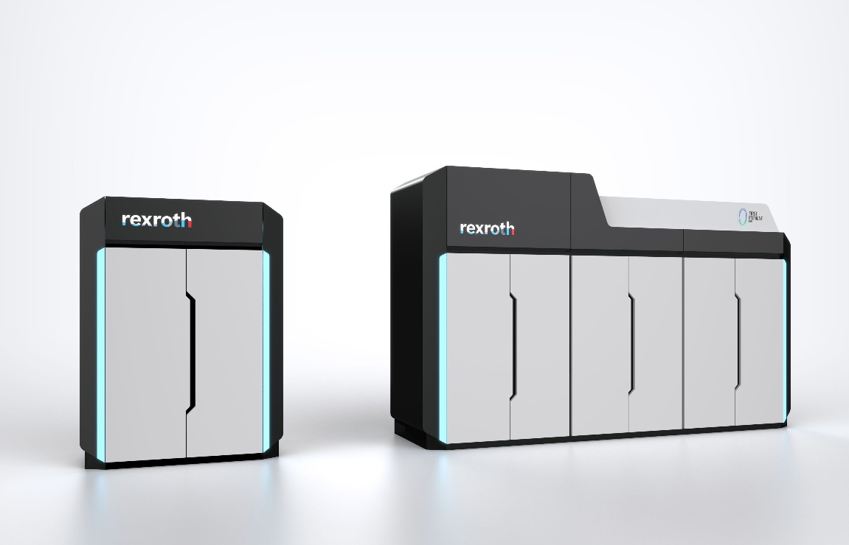

The CryoPump stations enable an efficient, economical and scalable refueling solution for mobility, heavy goods transport and logistics of the future. (Image source: Bosch Rexroth AG)

Bosch Rexroth is presenting new pump stations for hydrogen filling stations at the Hannover Messe. By using liquid hydrogen, they increase transport capacity, reduce operating costs by up to 70% and thus enable economical refueling. The stations are technologically flexible and enable refueling with both liquid and gaseous hydrogen – depending on the requirements of different vehicle concepts. Bosch Rexroth is setting new standards for the hydrogen filling stations of the future.

Robustness and efficiency thanks to hydraulic drive

The Bosch Rexroth cryopumps developed in collaboration with FirstElement Fuel, the market leader for the commercial operation of liquid hydrogen filling stations in the USA, are based on an electro-hydraulic drive concept with an extended stroke length, which reduces load changes and minimizes wear. Compared to conventional crankshaft-based pumps, the technology increases efficiency to over 95% and extends maintenance intervals to over 4,000 hours. The two-stage pump technology also allows both liquid and gaseous hydrogen to be pumped. This enables flexible storage concepts.

**Quiet and compact CryoPump stations for an efficient hydrogen infrastructure**

The electro-hydraulic drive technology of the pump stations enables quiet and space-saving operation. With a footprint of less than 11 m² and a noise level of less than 65 dB(A), they are ideal for use in existing filling stations, even in residential areas. The pump stations are an important basis for the worldwide expansion of an efficient hydrogen infrastructure.

**Lower hydrogen prices and faster amortization for operators**

Thanks to their high efficiency and minimal boil-off losses, CryoPump stations significantly reduce operating costs and can therefore contribute to lower hydrogen prices for end customers in the long term. The compact design enables easy integration into existing filling stations, making both new construction and retrofits significantly more cost-efficient. Operators benefit from lower investment hurdles and faster amortization. The robust design in combination with AI-supported condition monitoring enables predictive maintenance and ensures high plant availability. Investment costs can be reduced by up to 50% by dispensing with high-pressure accumulators and cooling power units. With a delivery rate of 600 kg/h, the CryoPump stations enable direct high-pressure refueling of a heavy-duty truck in less than ten minutes. This speeds up the refueling process, increases profitability for operators and significantly improves the everyday usability of hydrogen-powered commercial vehicles.

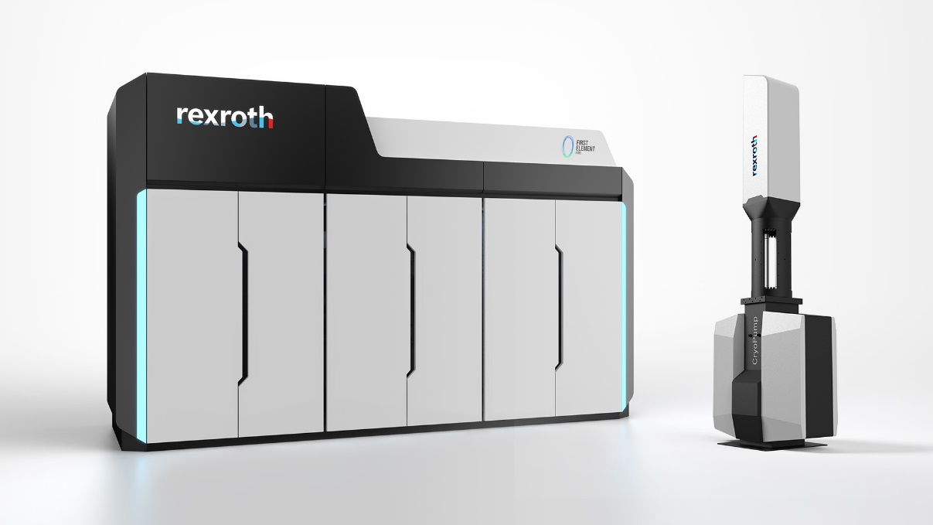Image 2: With a delivery rate of 600 kg/h, the CryoPump stations enable direct high-pressure refueling of a heavy-duty truck in less than ten minutes. (Image source: Bosch Rexroth AG)

**About Bosch Rexroth:**As one of the world’s leading suppliers of drive and control technologies, Bosch Rexroth ensures efficient, powerful and safe movement in machines and systems of any size. The company bundles global application experience in the market segments of Mobile and Industrial Applications as well as Factory Automation. With its intelligent components, customized system solutions, engineering and services, Bosch Rexroth is creating the necessary environment for fully connected applications. Bosch Rexroth offers its customers hydraulics, electric drive and control technology, gear technology and linear motion and assembly technology, including software and interfaces to the Internet of Things. With locations in over 80 countries, around 33,800 associates generated sales revenue of 7.6 billion euros in 2023. To learn more, please visit [www.boschrexroth-us.com](http://www.boschrexroth-us.com).

**About Bosch:**The Bosch Group is a leading global supplier of technology and services. It employs roughly 417,900 associates worldwide (as of December 31, 2024). According to preliminary figures,   
the company generated sales of 90.5 billion euros in 2024. Its operations are divided into   
four business sectors: Mobility, Industrial Technology, Consumer Goods, and Energy and Building Technology. With its business activities, the company aims to use technology to help shape universal trends such as automation, electrification, digitalization, connectivity, and an orientation to sustainability. In this context, Bosch’s broad diversification across regions and industries strengthens its innovativeness and robustness. Bosch uses its proven expertise in sensor technology, software, and services to offer customers cross-domain solutions from a single source. It also applies its expertise in connectivity and artificial intelligence in order to develop and manufacture user-friendly, sustainable products. With technology that is “Invented for life,” Bosch wants to help improve quality of life and conserve natural resources. The   
Bosch Group comprises Robert Bosch GmbH and its roughly 470 subsidiary and regional companies in over 60 countries. Including sales and service partners, Bosch’s global manufacturing, engineering, and sales network covers nearly every country in the world. Bosch’s innovative strength is key to the company’s further development. At 136 locations across the globe, Bosch employs some 86,900 associates in research and development, of which nearly 48,000 are software engineers. Additional information is available online at [www.bosch.com](http://www.bosch.com), [www.iot.bosch.com](http://www.iot.bosch.com), [www.bosch-press.com](http://www.bosch-press.com).