Bosch Rexroth to Demonstrate Innovative Linear Motion Technology for Automating Medical and Packaging Applications

The latest technology demos and informative exhibits highlight the latest in multi-axis Cartesian systems and compact position measuring systems in booth 5101 at MD&M West 2025 in Anaheim, CA.

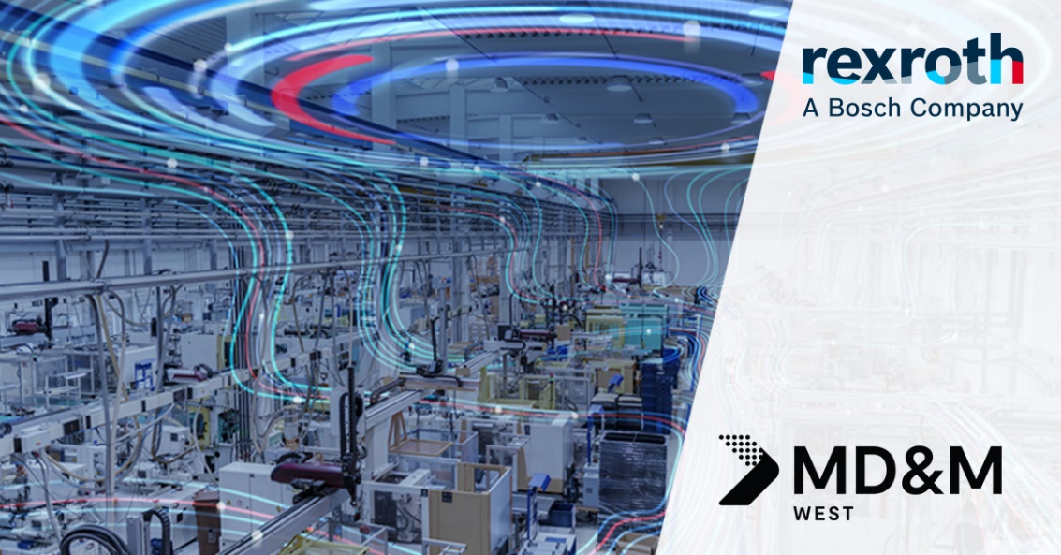

Demonstrations and booth presentations covering multiple Bosch Rexroth automation capabilities for medical and packaging will be featured at MD&M West 2025.

**Bosch Rexroth will showcase our robust linear technology portfolio, including best-in-class components, multi-axis cartesian systems and a compact integrated measuring system in booth 5101 at MD&M West 2025 on** **February 4-6 in Anaheim, California at the Anaheim Convention Center.**

Located in booth 5101, MD&M West attendees will have the opportunity to see how Bosch Rexroth serves the medical and packaging industries with linear systems that offer a harmonized combination of proven components, eTools, plug-and-produce commissioning, and application-specific software.

At the booth, immerse yourself in live and interactive demonstrations centered around linear system automation. Attendees can expect to see an interactive touch table highlighting precise and sustainable LT components, such as rails, screws, actuators, modules, etc. as well as a smart, multi-axis cartesian system consisting of best-in-class linear motion technology from Bosch Rexroth, the latest automation hardwares, and an open interface for easy integration into higher level systems.

Step into the future of measuring technology with our hologram display of the IMS-compact. This innovative measuring sensor is fully integrated into the carriage and uses a magnetic measuring principle to provide precise and reliable measurements. Available in both incremental and absolute variants, the IMS-compact offers new automation options when paired with linear motors. Customers will experience firsthand the benefit of a compact and virtually maintenance-free measuring system through the exhibit.

Bosch Rexroth Certified Excellence partner covering the pacific northwest, Northwest Motion, will be onsite to demonstrate their robust industry knowledge and regional support capabilities for integrating Bosch Rexroth’s linear motion technologies into automation systems. Northwest Motion will be exhibiting complementary technology offerings, including several demonstrations of ctrlX AUTOMATION and a [Kassow Robot](https://www.boschrexroth.com/en/us/company/acquisitions/kassow-robots/) seven-axes collaborative robot.

For more information, visit [www.boschrexroth-us.com/md&m-west](http://www.boschrexroth-us.com/md&m-west).

MD&M West attendees are invited to visit booth 5101 to learn more, directly from Bosch Rexroth’s experts.

**About Bosch Rexroth:**As one of the world’s leading suppliers of drive and control technologies, Bosch Rexroth ensures efficient, powerful and safe movement in machines and systems of any size. The company bundles global application experience in the market segments of Mobile and Industrial Applications as well as Factory Automation. With its intelligent components, customized system solutions, engineering and services, Bosch Rexroth is creating the necessary environment for fully connected applications. Bosch Rexroth offers its customers hydraulics, electric drive and control technology, gear technology and linear motion and assembly technology, including software and interfaces to the Internet of Things. With locations in over 80 countries, around 33,800 associates generated sales revenue of 7.6 billion euros in 2023. To learn more, please visit [www.boschrexroth-us.com](http://www.boschrexroth-us.com).

**About Bosch:**The Bosch Group is a leading global supplier of technology and services. It employs roughly 429,000 associates worldwide (as of December 31, 2023). The company generated sales of 91.6 billion euros in 2023. Its operations are divided into four business sectors: Mobility, Industrial Technology, Consumer Goods, and Energy and Building Technology. With its business activities, the company aims to use technology to help shape universal trends such as automation, electrification, digitalization, connectivity, and an orientation to sustainability. In this context, Bosch’s broad diversification across regions and industries strengthens its innovativeness and robustness. Bosch uses its proven expertise in sensor technology, software, and services to offer customers cross-domain solutions from a single source. It also applies its expertise in connectivity and artificial intelligence in order to develop and manufacture user-friendly, sustainable products. With technology that is “Invented for life,” Bosch wants to help improve quality of life and conserve natural resources. The Bosch Group comprises Robert Bosch GmbH and its roughly 470 subsidiary and regional companies in over 60 countries. Including sales and service partners, Bosch’s global manufacturing, engineering, and sales network covers nearly every country in the world. Bosch’s innovative strength is key to the company’s further development. At 136 locations across the globe, Bosch employs some 90,000 associates in research and development, of which nearly 48,000 are software engineers. Additional information is available online at [www.bosch.com](http://www.bosch.com), [www.iot.bosch.com](http://www.iot.bosch.com), [www.bosch-press.com](http://www.bosch-press.com).