eSEA Spin launches: Bosch Rexroth and WITTENSTEIN unveil multiturn subsea actuator at OTC 2025 in Houston

Joint development of eSEA Spin from Bosch Rexroth and WITTENSTEIN motion control electrifies the operation of flow valves in subsea systems.

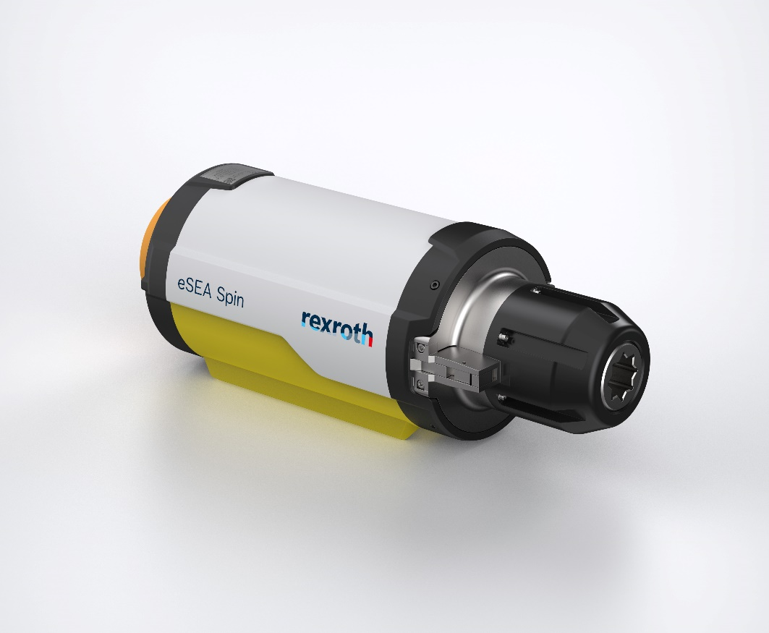

With the eSEA Spin, Bosch Rexroth and WITTENSTEIN are shaping the future of fully electric actuators in subsea technology. (photo courtesy of Bosch Rexroth AG)

Viable business models for the production of green hydrogen at sea or the storage of CO2 under the seabed (CCS) depend on cost-effective subsea technology. That is why Bosch Rexroth AG and WITTENSTEIN motion control GmbH have jointly developed the electromechanical eSEA Spin subsea actuator for continuously variable flow control of gases and fluids. It is operated at a water depth of up to 4.000 m via a 24 V power supply and therefore doesn’t require any hydraulic pipes from the water surface to the seabed. This reduces both the investment costs for the entire subsea system and the operating costs in the long term.

Joint development based on proven components

The development of the eSEA Spin is not only a technological achievement, but also proof of successful cooperation. By combining the expertise of WITTENSTEIN in the field of gearbox technology with the expertise of Bosch Rexroth in automation and electronics, we are developing solutions that offer real added value for our customers. “Together, we are shaping the future of fully electric actuators in subsea technology,” summarizes Dr. Steffen Haack, CEO of Bosch Rexroth AG.

“Bosch Rexroth and WITTENSTEIN both have many years of proven application experience in the field of subsea technology. Our gearboxes and electromechanical modules are designed for the required service life of more than 25 years in the sea – and have already proven themselves many times over this long period of time,” says Dr. Bertram Hoffmann, CEO of WITTENSTEIN SE.

Electric actuator replaces hydraulics

Previously, valves in subsea systems have mostly been operated by unmanned, remotely operated vehicles (ROVs), or hydraulically and must be supplied with a hydraulic pipe from the water surface. The eSEA Spin is just as compact as hydraulic modules and adjusts throttle valves rotationally with a torque of up to 2700 Nm while only requiring electrical power of maximum 480 watts. The power is supplied to two redundant 24 V motors, each with its own controllers, which generate unlimited rotational movements for precise flow control via a planetary gearbox.

Intelligent software maximizes availability

The robust control electronics are based on a control system from the automotive sector, which is produced in very large quantities and of high quality. In addition, industrial sensors for condition monitoring continuously collect operating data, such as the absolute position and the torque. This enables precise flow control of the valve. “Bosch Rexroth has the software expertise and experience to filter the relevant information from this data, to link them to the integrated digital twins of the components and thus significantly improve the availability of the actuator over the entire period of use,” says Haack.

Standardized interfaces for mechanics and communication

The new actuator features a mechanical ROV Class 4 interface and a SIIS L2 interface for electrical power supply and communication with higher-level systems on the offshore platform. The drive module can be integrated in just a few minutes.

The relocation of functions to the software reduces the complexity and the acquisition costs compared to actuators currently available on the market. The eSEA Spin integrates into the electrical 24 V infrastructure of subsea systems without any additional effort and makes it possible to actuate the valves even at greater distances, known as ‘step-out’ distances. The low energy consumption reduces operating costs over the entire service life. The new actuator complements the eSEA portfolio from Bosch Rexroth for linear and rotary movements that control subsea valves with different functions and requirements. A 24 V power supply is sufficient and a hydraulic system with pipes to the seabed is no longer necessary in the future. This electrification reduces the hurdles for the commercial production of green hydrogen at sea or the storage of CO2 in reservoirs below the seabed.

Launch of the eSEA Spin at OTC 2025

At the Offshore Technology Conference (OTC) 2025, taking place from May 5 to 8 at NRG Park in Houston, the eSEA Spin will be presented for the first time to the conference attendees. Under the theme “Waves of Innovation >> Offshore Energy Excellence,” the conference will highlight groundbreaking advancements in offshore energy. Bosch Rexroth and WITTENSTEIN will be exhibiting together at booth #3219, where they will share exciting insights into the development of the new multiturn actuator. At the booth, visitors can experience the product in its original size.

A technical presentation focusing on the advancements of the multiturn actuator, titled “Ensuring Precise Flow Control: Optimized Multiturn Actuation for Low-Power Applications,” is scheduled for Tuesday, May 6, at 10:30 AM in Room 312, as part of the session “Enhancing Offshore Production: New Approaches to Flow Assurance, Corrosion, and Scale Control.”

**About Bosch Rexroth:**  
As one of the world’s leading suppliers of drive and control technologies, Bosch Rexroth ensures efficient, powerful and safe movement in machines and systems of any size. The company bundles global application experience in the market segments of Mobile and Industrial Applications as well as Factory Automation. With its intelligent components, customized system solutions, engineering and services, Bosch Rexroth is creating the necessary environment for fully connected applications. Bosch Rexroth offers its customers hydraulics, electric drive and control technology, gear technology and linear motion and assembly technology, including software and interfaces to the Internet of Things. With locations in over 80 countries, around 32,600 associates generated sales revenue of 6.5 billion euros in 2024. To learn more, please visit [www.boschrexroth-us.com](http://www.boschrexroth-us.com).

**About Bosch:**The Bosch Group is a leading global supplier of technology and services. It employs roughly 417,900 associates worldwide (as of December 31, 2024). According to preliminary figures,   
the company generated sales of 90.5 billion euros in 2024. Its operations are divided into   
four business sectors: Mobility, Industrial Technology, Consumer Goods, and Energy and Building Technology. With its business activities, the company aims to use technology to help shape universal trends such as automation, electrification, digitalization, connectivity, and an orientation to sustainability. In this context, Bosch’s broad diversification across regions and industries strengthens its innovativeness and robustness. Bosch uses its proven expertise in sensor technology, software, and services to offer customers cross-domain solutions from a single source. It also applies its expertise in connectivity and artificial intelligence in order to develop and manufacture user-friendly, sustainable products. With technology that is “Invented for life,” Bosch wants to help improve quality of life and conserve natural resources. The   
Bosch Group comprises Robert Bosch GmbH and its roughly 470 subsidiary and regional companies in over 60 countries. Including sales and service partners, Bosch’s global manufacturing, engineering, and sales network covers nearly every country in the world. Bosch’s innovative strength is key to the company’s further development. At 136 locations across the globe, Bosch employs some 86,900 associates in research and development, of which nearly 48,000 are software engineers. Additional information is available online at [www.bosch.com](http://www.bosch.com), [www.iot.bosch.com](http://www.iot.bosch.com), [www.bosch-press.com](http://www.bosch-press.com).