Bosch Rexroth to showcase the latest technologies for offshore and marine applications at OTC 2025

Booth demonstrations and special presentations will highlight innovative technologies that combine efficiency, safety, environmental stability, and connectivity at OTC 2025 in Houston.

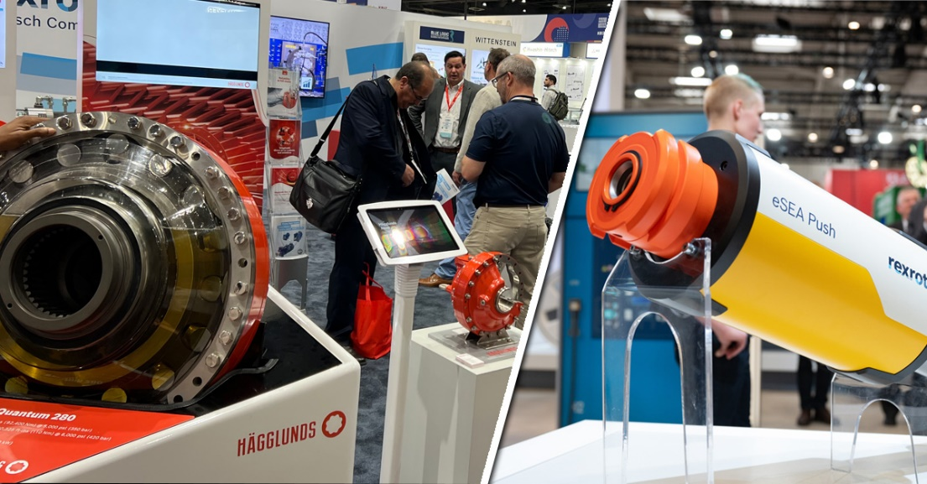

Discover Bosch Rexroth’s advanced technologies for offshore and marine applications at the Offshore Technology Conference (OTC) 2025.

Bosch Rexroth will join offshore and marine technology experts to showcase the company’s latest innovations at OTC 2025 on May 5-8 in Houston, TX. Located at booth 3219, Rexroth and Hägglunds displays will showcase a range of products and solutions that support the offshore technology sector.

At OTC 2025, visitors to the Bosch Rexroth booth will have the opportunity to learn about the company’s latest technologies and solutions for marine and offshore applications through interactive demonstrations and presentations of motors and drive systems, innovative subsea systems for efficiency, and more.

Highlights of this year’s booth include the **2025 Spotlight on New Technology** award-winner, the Hägglunds Fusion. In the Fusion drive, the entire hydraulic drive system is mounted on the torque arm – motor, cabinet, pumps and all. And making its debut for the first time at OTC 2025 is the eSEA Spin. Developed jointly with Bosch Rexroth AG and WITTENSTEIN motion control GmbH, the electromechanical eSEA Spin subsea actuator is designed for continuously variable flow control of gases and fluids. It is operated at a water depth of up to 4000 m via a 24 V power supply and doesn’t require any hydraulic pipes from the water surface to the seabed. This reduces both the investment costs for the entire subsea system and the operating costs in the long term.

Also on display is the2024 Spotlight on New Technology award-winner, Hägglunds Quantum Power – high power with greater economy and sustainability, and our pioneering portfolio of easy-to-use Subsea Electric Actuators (eSEA) to enable the lean electrification of any subsea production system or process valve.

In addition, Bosch Rexroth subsea technology experts Markus Kubacki, Joao Pedro Duarte da Silva, and Eva-Maria Pfeifroth will present three technical/poster sessions at the show. Stop in to see the presentation titled *“Ensuring Precise Flow Control: Optimized Multiturn Actuation for Low-Power Applications”* on Tuesday, May 6, from 10:30-10:48 AM CT – Room 312, *“Design For Reliability: Enabling Enhanced Condition Monitoring in All-Electric Subsea Systems”* on Wednesday, May 7, from 4:00-4:18 PM CT – Room 312, and *“Enhancing System Availability: Findings and Potentials Discovered During the Electrification of Large Subsea Valves”* located in the ePoster Lounge on Thursday, May 8, from 10:30-10:48 AM CT.

**Other key exhibits at OTC 2025 include:**

The 2023 Spotlight on New Technology winner, Subsea Valve Actuator (SVA R2) is the world’s first electric actuator that can replace conventional hydraulic cylinders with proven safety technology and without taking up additional space.

The 2023 Spotlight on New Technology winner, Hägglunds Atom comes bundled in an extremely compact design that withstands harsh environments and mounts right on the shaft. Fully marine adapted, the atom is a powerhouse in miniature, unleashing a maximum torque of 13.6 kNm at speeds of up to 400 rpm, ideally suited for marine equipment such as winches, thrusters, dredgers and subsea mining.

Rineer vane motors provide high torque at start and stall and flat torque throughout the entire speed range. The “vane-crossing-vane” design provides optimum power-to-weight ratio, smooth output over a wide speed range and maximum torque at zero rpm.

The Rexroth eLION electrification portfolio offers robust benefits designed to enhance productivity and reliability in oil and gas and other demanding industries. Its IP6K9K rating, combined with high vibration and shock resistance, ensures durability even in the harshest environments. eLION gearboxes are engineered for high-speed electric motor operation, making them ideal for winch applications in wireline and drilling sectors. eLION provides hardware and software solutions for power generation, both as a backup to shore power or when shore power is unavailable, eliminating downtime.

For more information, visit [www.boschrexroth-us.com/otc](http://www.boschrexroth-us.com/otc). OTC attendees are invited to visit booth #3219 to learn more, directly from Rexroth’s experts.

**About Bosch Rexroth:**  
As one of the world’s leading suppliers of drive and control technologies, Bosch Rexroth ensures efficient, powerful and safe movement in machines and systems of any size. The company bundles global application experience in the market segments of Mobile and Industrial Applications as well as Factory Automation. With its intelligent components, customized system solutions, engineering and services, Bosch Rexroth is creating the necessary environment for fully connected applications. Bosch Rexroth offers its customers hydraulics, electric drive and control technology, gear technology and linear motion and assembly technology, including software and interfaces to the Internet of Things. With locations in over 80 countries, around 32,600 associates generated sales revenue of 6.5 billion euros in 2024. To learn more, please visit [www.boschrexroth-us.com](http://www.boschrexroth-us.com).

**About Bosch:**The Bosch Group is a leading global supplier of technology and services. It employs roughly 417,900 associates worldwide (as of December 31, 2024). According to preliminary figures,   
the company generated sales of 90.5 billion euros in 2024. Its operations are divided into   
four business sectors: Mobility, Industrial Technology, Consumer Goods, and Energy and Building Technology. With its business activities, the company aims to use technology to help shape universal trends such as automation, electrification, digitalization, connectivity, and an orientation to sustainability. In this context, Bosch’s broad diversification across regions and industries strengthens its innovativeness and robustness. Bosch uses its proven expertise in sensor technology, software, and services to offer customers cross-domain solutions from a single source. It also applies its expertise in connectivity and artificial intelligence in order to develop and manufacture user-friendly, sustainable products. With technology that is “Invented for life,” Bosch wants to help improve quality of life and conserve natural resources. The   
Bosch Group comprises Robert Bosch GmbH and its roughly 470 subsidiary and regional companies in over 60 countries. Including sales and service partners, Bosch’s global manufacturing, engineering, and sales network covers nearly every country in the world. Bosch’s innovative strength is key to the company’s further development. At 136 locations across the globe, Bosch employs some 86,900 associates in research and development, of which nearly 48,000 are software engineers. Additional information is available online at [www.bosch.com](http://www.bosch.com), [www.iot.bosch.com](http://www.iot.bosch.com), [www.bosch-press.com](http://www.bosch-press.com).