Hägglunds to Exhibit Full Range of Motor & Drive Technology at SME MINEXCHANGE 2025

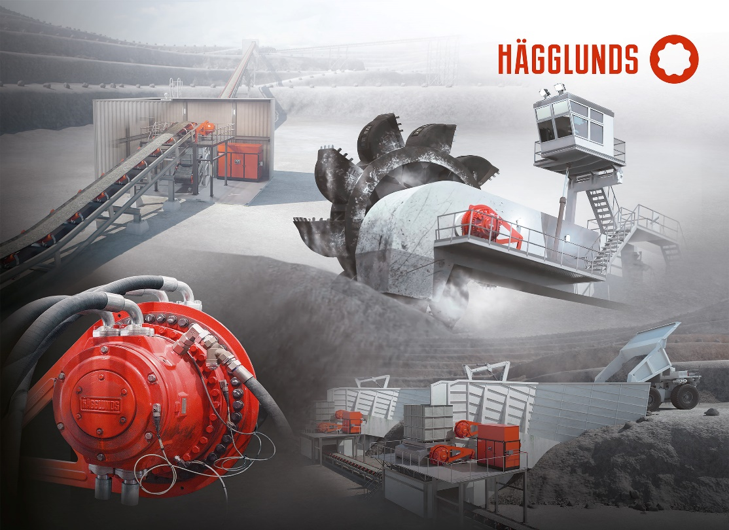Show demos will highlight power and performance of Hägglunds solutions in booth 1246 at MINEXCHANGE 2024 in Denver, CO

Multiple Hägglunds direct drive systems will be on display offering solutions for key mining applications.

Hägglunds will exhibit its full range of industry-leading direct drive hydraulic motors, products and services in booth 1246 at MINEXCHANGE 2025, Feb. 23–26, in Denver, CO.

The products and solutions Hägglunds will showcase at MINEXCHANGE leverage the unique characteristics of hydraulic direct drive technology — delivering power directly to the drive shaft with full torque from zero speed and protection from shock loads — to maximize the efficiency and uptime of conveyors, feeders, crushers, drums, bucket wheel reclaimers, kilns and more.

System demonstrations and booth presentations will highlight the unique features Hägglunds technology offers, including:

**Torque Control:** Direct drives with low speed and high torque can provide full torque from standstill, without time restrictions. Hägglunds hydraulic direct drives can operate continuously throughout their power range up to their rated torque, from zero to full speed.

**Start-Stop-Reverse:** A Hägglunds hydraulic direct drive reacts especially quickly due to its very low moment of inertia. They are able to switch automatically from driving to braking mode, and the direction of rotation can be switched quickly by changing the direction of the oil flow.

**Shock Load Resistance:** Shock loads can damage critical equipment and lead to major unplanned downtimes. With direct drive motors applying power directly to the core of conveyors, crushers and feeders, the direct drive offers a solution without mechanical play and with a low moment of intertia so it can easily withstand vibrations, external shock loads and changing load directions.

*Key solutions and technology that will be presented in the booth include:*

**Quantum Family:** Hägglunds Quantum is the new name for the Hägglunds CB, which has evolved so significantly over time that it can no longer be considered the same motor. Tweaks in design and materials have increased its efficiency and tripled its life expectancy, making it the ideal basis for a bold new step. That step is the Hägglunds Quantum Power, which merges a slim new connection block with this reliable foundation. Through additional ports and innovative internal design, the block enables far higher speeds while retaining full torque capacity at high efficiency.

**Atom Hydraulic Motor:** Combining the right size with Hägglunds performance, it offers the right fit for mining applications where both compact size and high power density are required. With a maximum torque of up to 13.6 kNm and a specific torque of 40 Nm/bar, the Hägglunds Atom hydraulic motor can supply maximum power of 394 kW, outstripping other motors in its class.

**Rineer Motors:** Bosch Rexroth’s Rineer motors offer the highest power density with maximum torque, as well as robustness, even under the most adverse climatic conditions and high dirt loads. Our Rineer motors are frequently used in the mining and construction sectors, on drilling and winch applications.

In addition to those exhibits, booth visitors can meet one-on-one with Hägglunds technology experts to discuss their unique challenges and requirements. Experts can provide practical recommendations on ways that the Hägglunds technology can help maximize uptime and productivity in mining operations.

For more information, visit [www.boschrexroth-us.com/sme](http://www.boschrexroth-us.com/sme).

For more information on Hägglunds, visit [www.boschrexroth-us.com/hagglunds](http://www.boschrexroth-us.com/hagglunds).

***About Hägglunds:****Hägglunds stands for groundbreaking direct hydraulic drive technology and unwavering customer focus. Engineered and manufactured in Mellansel, Sweden, Hägglunds hydraulic motors and compact direct drive systems provide superior torque performance, flexibility, and reliability to customers worldwide. Hägglunds is a brand of Bosch Rexroth, a leading global supplier of drive and control technologies. To learn more about Hägglunds solutions, visit* [*www.boschrexroth-us.com/hagglunds*](http://www.boschrexroth-us.com/hagglunds)*.*

***About Bosch Rexroth:****As one of the world’s leading suppliers of drive and control technologies, Bosch Rexroth ensures efficient, powerful and safe movement in machines and systems of any size. The company bundles global application experience in the market segments of Mobile and Industrial Applications as well as Factory Automation. With its intelligent components, customized system solutions, engineering and services, Bosch Rexroth is creating the necessary environment for fully connected applications. Bosch Rexroth offers its customers hydraulics, electric drive and control technology, gear technology and linear motion and assembly technology, including software and interfaces to the Internet of Things. With locations in over 80 countries, around 33,800 associates generated sales revenue of 7.6 billion euros in 2023. To learn more, please visit* [*www.boschrexroth-us.com*](http://www.boschrexroth-us.com)*.*