Note: This form below is only for field service activities, do not use this form for spare parts or repair requests.
For spare parts, please contact SpareParts.BetP@us.bosch.com
For repairs, please contact Service.Repair@boschrexroth-us.com

Only Proceed If Field Service is still required.
Industrial Hydraulics Field Service Request Form Instructions
- Please review the instruction provided with large red text.
- Option 1 preferred, download the PDF copy of the form below
- Option 2 a word document is also supplied.
- Open the document fill out the required data, include technical information and email as instructed to Field.Service-IHD@us.bosch.com
- For any other questions concerning Field Service please email- Field.Service-IHD@us.bosch.com
Contact Information and dates requested section
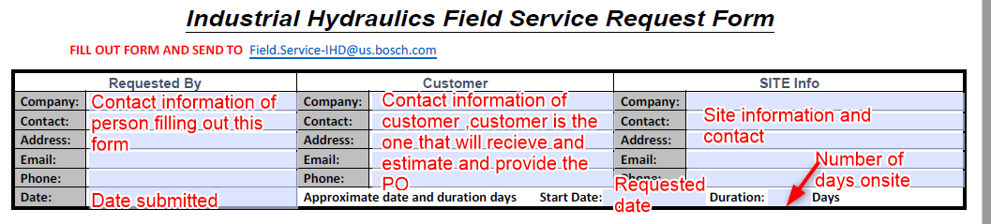

Bosch Rexroth internal Warranty information

Main Body, Complaint and Task/Role required
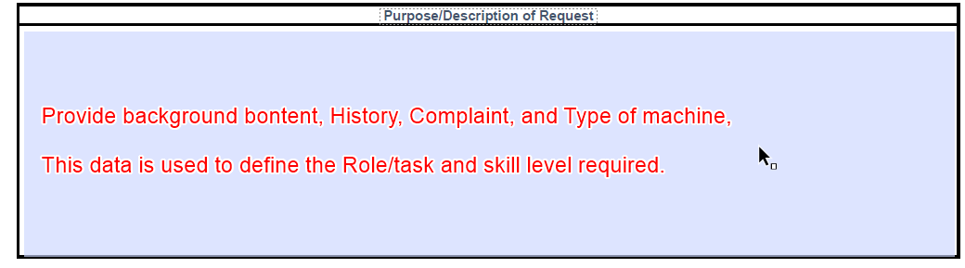

Technical Data and Parts information
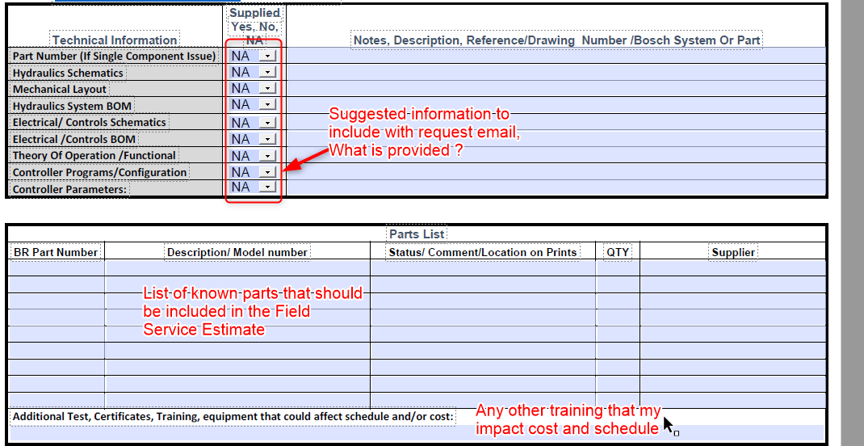

Industrial Hydraulics Field Service Request Forms Formats
- Open document, add information, save and email along with any associated technical information/documents.

Option 1 (Preferred) PDF format OR Option 2 MS Word Format

